**EMPATHY MAP**

**--------------------------------------------------------------------------------------------**

|  |  |
| --- | --- |
| NAME | T.SURESH KUMAR |
| NM ID | EA32343CFBC1AD09D4E465F983490A2F |
| PROJECT | HOW TO CREATE A GOOGLE ADS COMPAIGN FOR YOUR BRAND |

**EMPATHY MAP:**

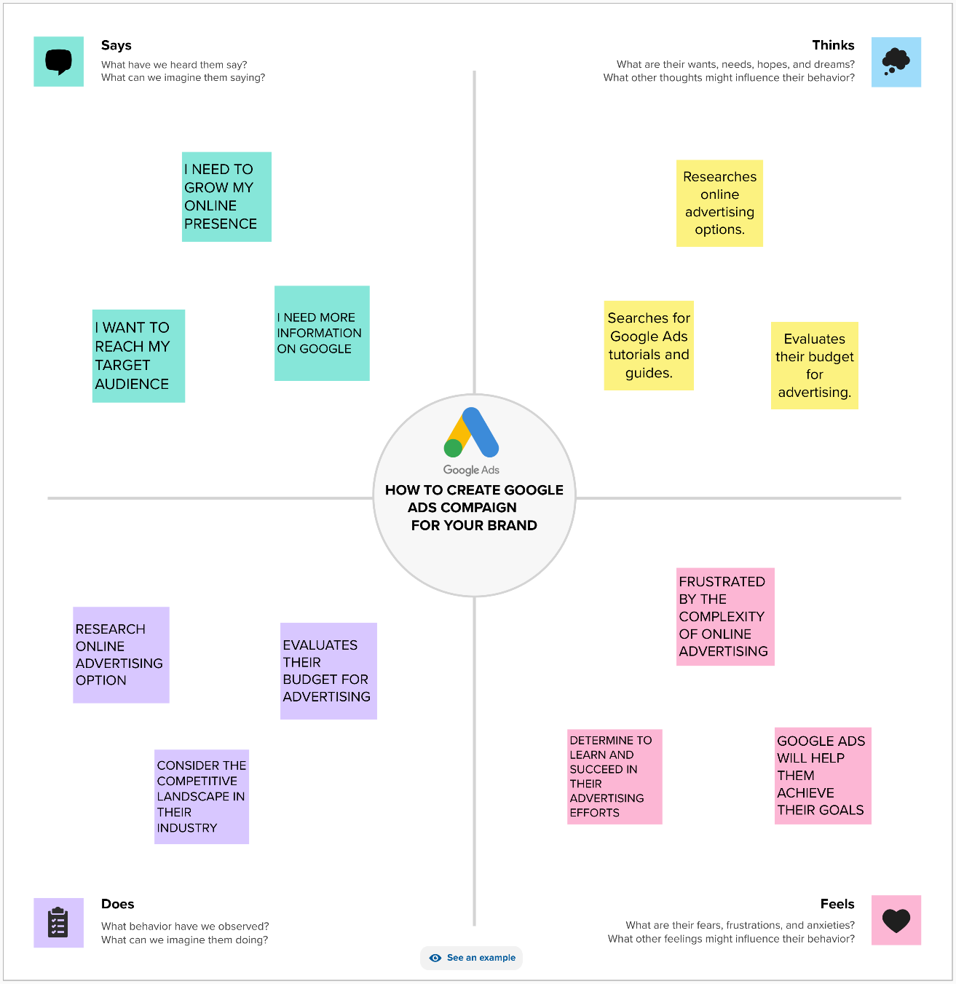

**EMPATHY MAP LINK:** <https://app.mural.co/t/suresh8378/m/suresh8378/1698852627354/fa012415751f9725e867fe96537cabefcf0b6479?sender=u30a67f9b441b4e205e280708>